OOPS (PPF)
Mini-Project Assignment
Name: Anjali Kumari | Roll No: 2556427 | Branch: Btech CSE B1 Semester: 3rd | Date of Submission: 27/10/26
Shape Area & Perimeter Calculator
---------------------------------------------------------------------------------
Problem Statement
Develop a calculator that computes the area and perimeter of different shapes through a common interface.

Class Design
Shape (Base Class)
|
----------------------------
| | |
Circle Rectangle Triangle

- Shape is an abstract base class that declares the virtual area() and perimeter() functions.
- Circle, Rectangle, and Triangle inherit from Shape.
- Each derived class implements its own formulas.
- The Shape* pointer calls the appropriate functions at runtime

Features
- Calculates the area and perimeter of a circle.
- Calculates the area and perimeter of a rectangle.
- Calculates the area and perimeter of a triangle.
- Uses a menu-driven console interface.
- Checks for invalid dimensions.
- Allows users to perform multiple calculations until they choose to exit.

OOPS CONCEPTS USED
- Classes and Objects: Each shape is represented using a class.
- Inheritance: Circle, Rectangle, and Triangle inherit from the Shape class.
- Abstraction: The Shape class defines common pure virtual functions for calculating area and perimeter, becoming an abstract class.
- Virtual Functions: The area() and perimeter() functions are declared as virtual functions.
- Function Overriding: Each derived class provides its own implementation of the functions.
- Runtime Polymorphism: A base-class pointer is used to call the appropriate functions for each shape.
- Encapsulation: Shape dimensions are stored as private data members.

Formulas Used
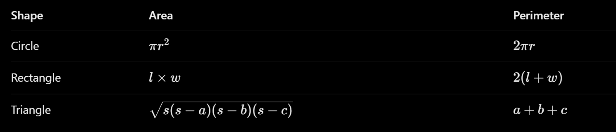

Invalid Inputs
- Menu Choices outside 1-4 are rejected.
- Input Values (for side/length/width/radius) must be greater than 0.
- Input values must be numeric.
- A triangle sides must satisfy that sum of any two sides always greater than third side for them to be valid.

Test Cases
- Circle Output
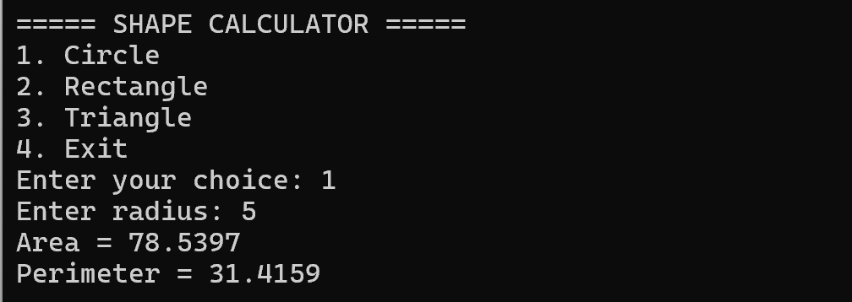

- Rectangle Output
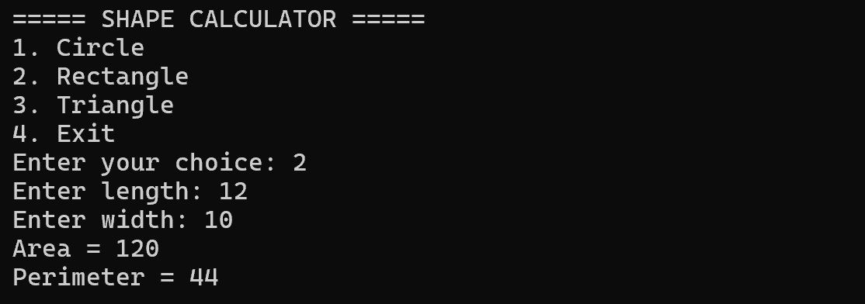

- Triangle Output
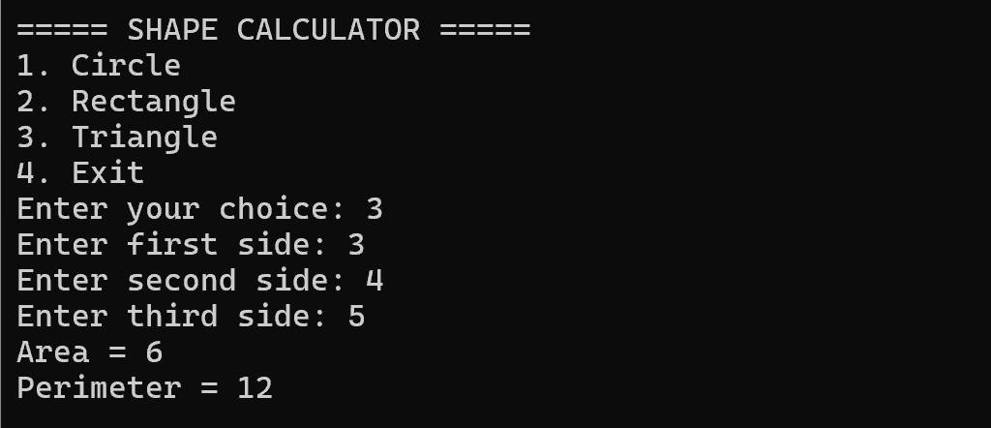

- Invalid Choice Given
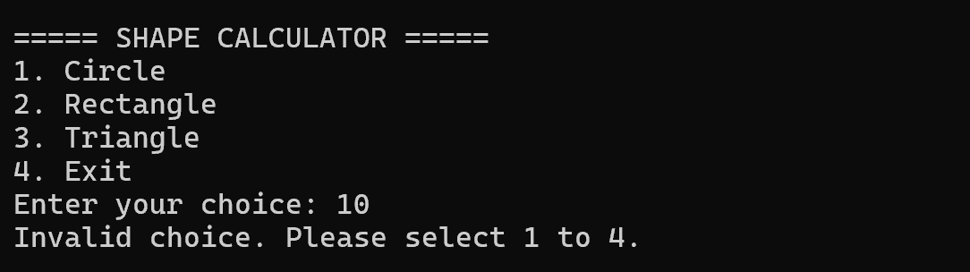

- Invalid non-numeric input given
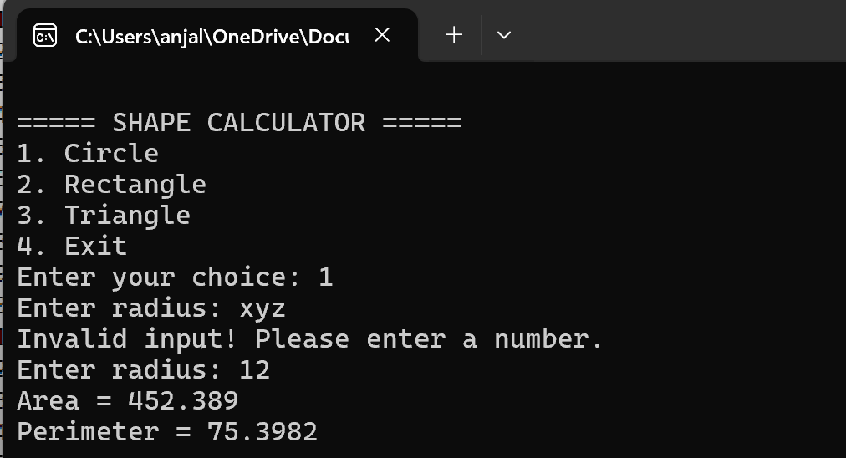

- Invalid negative sides given
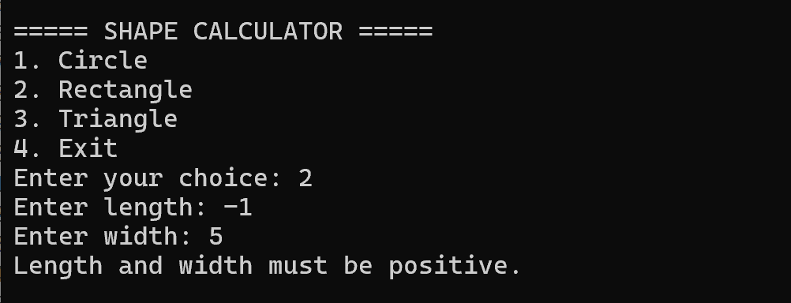

- Invalid triangle sides (sum of two sides not greater than or equal to third side)
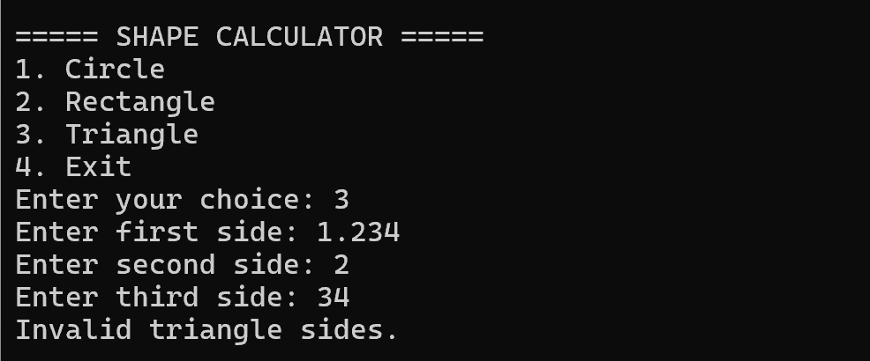

Conclusion
The Shape Area & Perimeter Calculator calculates the area and perimeter of circles, rectangles, and triangles using mathematical formulas. It uses OOPS concepts such as classes and objects, inheritance, encapsulation, abstraction, virtual functions, function overriding, and runtime polymorphism. The program also validates user inputs and handles invalid dimensions to ensure accurate calculations. Its menu-driven interface makes the program simple, organized, and user-friendly.

